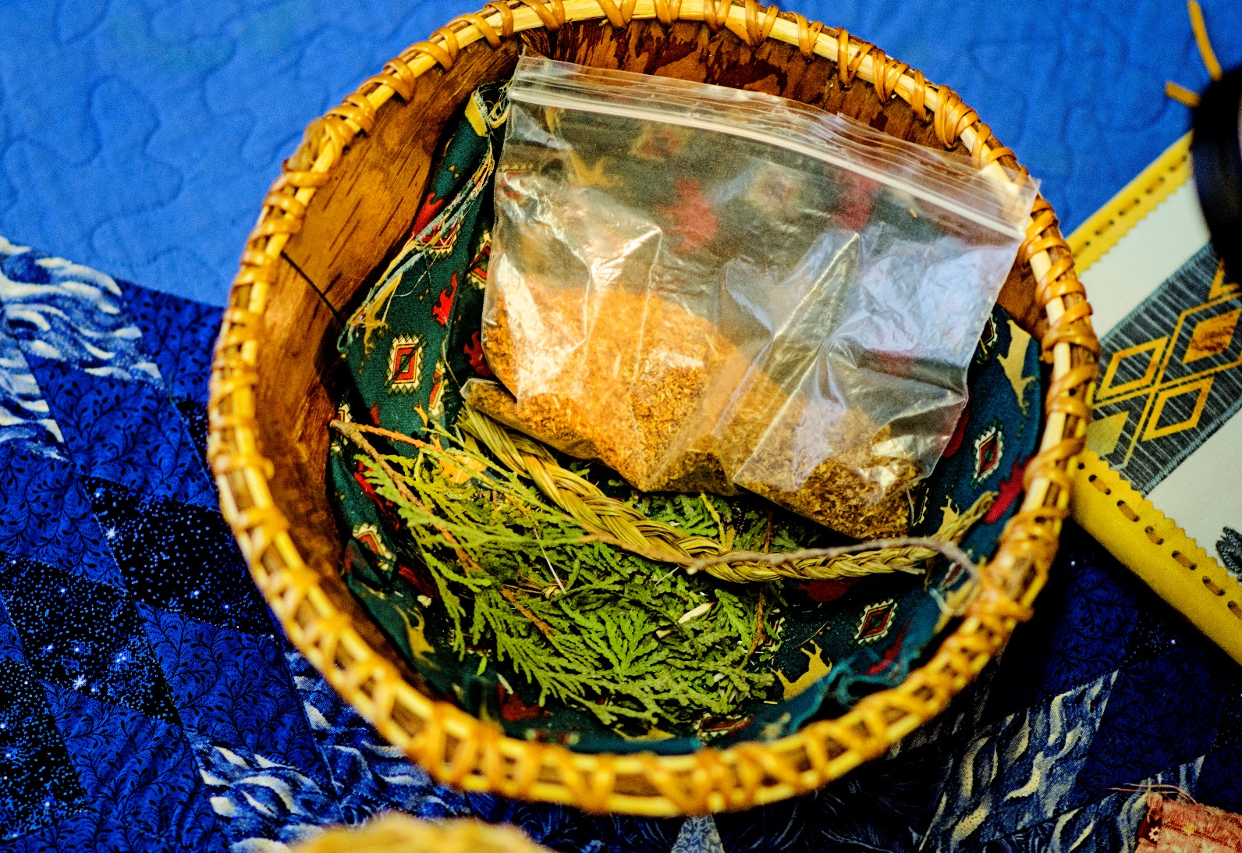

**Grief Edu-Therapy HEALING YOUR HEART.**

**This program is designed to provide the most effective tools for dealing with conflicting emotions caused by loss, and provide caregivers, grievers and educators with heart-helpful Edu-Therapy processes**

***LIGHT SNACKS & BUS TICKETS PROVIDED---PROGRAM IS FREE TO ATTEND!!!***

**WHERE?: 401 N. Cumberland St (at the Thunder Bay Indigenous Friendship Centre-BOARDROOM)**

**WHEN?: October 31 , November 6, 13th , 20th , 27th, December 4, 11, 18th, 2019 from 11 am to 2pm**

**We welcome you to take this journey with us in a safe environment-CALL TO REGISTER TODAY!!! # 345-5840 ext. 9095- Ask for Rebecca McLean ☺**

**Healing Your Heart….**