PIPE CEREMONY
HEALING WITHIN
CULTURAL TEACHING
MONDAY SEPTEMBER 16, 2019
6 TO 8 PM
THUNDER BAY INDIGENOUS FRIENDSHIP CENTER
BACK DOOR
ALL ARE WELCOME
SNACKS PROVIDED

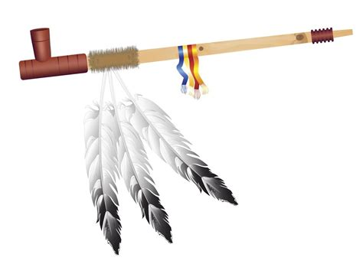

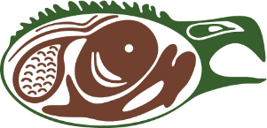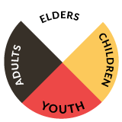
Contact: Cultural Resource Coordinator-Nathaniel Moses. nathaniel.moses@tbifc.ca for information.
@ 807-345-5840 Ext 9058 Thunder Bay Indigenous Friendship Center

