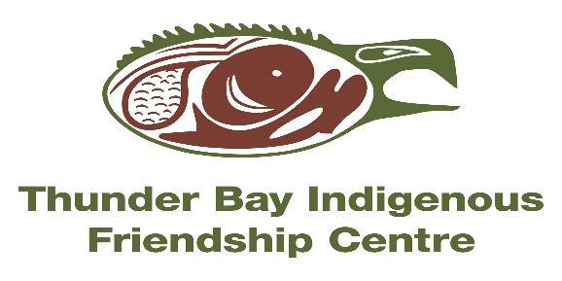**NIISHIN NEEN translates to “nice me” in Ojibway. This is a culturally based 7 Module Anger Management Program developed to help people heal and learn new skills! It incorporates the Seven Grandfather Teachings to provide strategies & techniques to use in our daily lives.**

**NIISHIN NEEN**

***LIGHT SNACKS & BUS TICKETS PROVIDED---PROGRAM IS FREE TO ATTEND!!!***

**WHERE?: 401 N. Cumberland St (at the Thunder Bay Indigenous Friendship Centre-BOARDROOM)**

**WHEN?: Thursdays from 5:00-8:00pm (April 11 to May 23, 2019)**

**We welcome you to take this journey with us in a safe environment-CALL TO REGISTER TODAY!!! # 345-5840 ext. 9080 or 9095- Ask for Diana or Rebecca ☺**