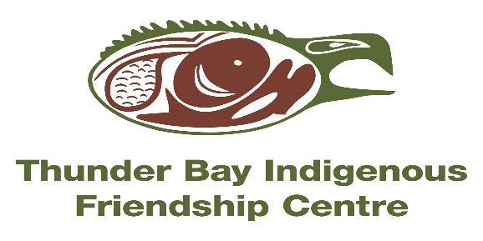
NIISHIN NEEN translates to “nice me” in Ojibway. This is a culturally based 7 Module Anger Management Program developed to help people heal and learn new skills! It incorporates the Seven Grandfather Teachings to provide strategies & techniques to use in our daily lives.
NIISHIN NEEN
LIGHT SNACKS & BUS TICKETS PROVIDED---PROGRAM IS FREE TO ATTEND!!!
WHERE?: 401 N. Cumberland St (at the Thunder Bay Indigenous Friendship Centre-BOARDROOM)
WHEN?: Thursdays from 5:00-8:00pm (Nov 1 – Dec 20, 2018)
We welcome you to take this journey with us in a safe environment-CALL TO REGISTER TODAY!!! # 345-5840 ext. 9082- Ask for Loretta Kwandibens

