- xavier michon  Volunteer appreciation  2017-2018  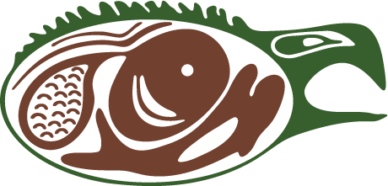  Welcome to our Annual Xavier Michon Awards & Volunteer Appreciation Event!!! Tonight we pay tribute to all of the history, hard work and dedication that goes into making our Thunder Bay Indigenous Friendship Centre a continued success. Without our volunteers and their countless contributions this would not be possible! YOU ARE OUR STARS!!! |  | In 1964 the young people, under the capable direction and leadership of Mr. Xavier Michon, started one of the first Friendship Centres in Canada. In the beginning, they met in church basements and halls, until they were able to rent an old tarpaper shack on the corner of North Cumberland Street and Clavet in what was known as the city of Port Arthur. This became a “home away from home” for some 500 Native youth, many of them students from far northern isolated communities. Out of necessity, they were sent to Thunder Bay to attend high schools and for most, it was their first time being away from their communities and families. The Native Youth Club became their organization and outlet for activity. The Centre was where they grew to become the leaders of today.  - TBIFC Website -  Thunder bay indigenous friendship centre  401 N. cumberland ST.  thunder bay, on  # 345-5840  www.tbifc.ca

Xavier Michon Day
- Friday, March 23rd 2018 -
Time | Activity
5:30 pm | Doors Open
6:00 pm | Opening Prayer and Songs  Feast
6:30 pm | Entertainment
7:30 pm | Volunteer Appreciation Presentations
8:30 pm | Closing of Xavier Michon Event
8:30 pm | Family Dance!  Doors are open to the public, everyone is welcome to attend!
10:30 pm | Dance Ends  Miigwech for coming!

Miigwech to all our Volunteers!
Thunder Bay Indigenous Friendship Centre
Thunder Bay, ON P7A 4P7
Phone: 807-345-5840
