THUNDER BAY INDIGENOUS FRIENDSHIP CENTRE
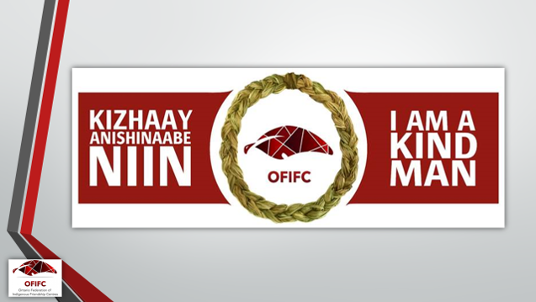

The Kizhaay Anishinaabe Niin program is to engage men of our communities to:
- Reclaim and revitalise men’s responsibility to end violence against Indigenous women;
- Ensure access to Indigenous cultural values and to increase understanding of traditional roles and responsibilities of men based on local Indigenous knowledge;
- Promote resiliency by empowering men to acknowledge and resolve trauma; and
- Improve men’s well-being and foster community wellness
This non–violence education program is not anger management or group therapy. Developed by the Ontario Federation of Indigenous Friendship Centres the material follows the Healthy Indigenous Male Curriculum and the Duluth Model “Creating a Process of Change for Men Who Batter”
The next 12 week program begins on January 25, 2018 to April 12, 2018 and will take place at the Thunder Bay Indigenous Friendship Centre Thursday evenings from 6:00 to 9:00pm. Bus tickets and snacks will be provided.
For more information or to register please contact:
Thunder Bay Indigenous Friendship Centre Kizhaay Anishinaabe Niin Worker
Marco Pasinelli
@ 345-5840 ext. 9079 or
marco.pasinelli@tbifc.ca

