Thunder Bay Indigenous Friendship Centre

Family Adventures at
Gammondale Farm

Thursday, October 26th 2017
Bus Departs TBIFC at 5:00 pm
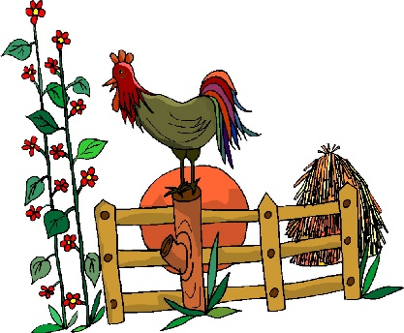
Bus Departs Gammondale at 7:00 pm

Thunder Bay Indigenous Friendship Centre
(Back Door)
401 Cumberland St N.
Thunder Bay, ON

-Wagon Rides – Farm Animals – Boo Barn – Pumpkin Train –
- Forest Maze – Monster Corn Maze – Duck Races –
- Trike Trail – Hay Bayle -

Registration required – please call 345-5840
Visit us online at www.tbifc.ca for more program information.

