WALK THIS WAY

A FREE URBAN POLE WALKING GROUP
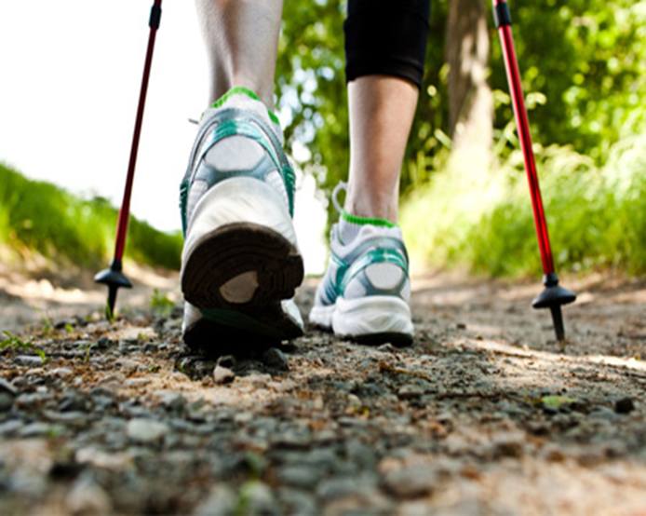 |  | Discover a new way of walking!  Urban pole walking is a fun and effective low impact, full-body workout for people of all ages and fitness levels.  Everyone is welcome!  No experience required!

Tuesdays

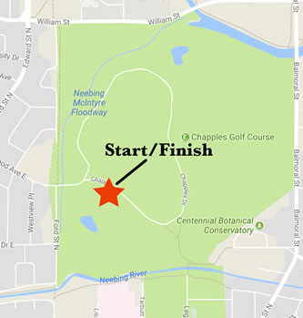
September 26 to November 7
6:00 pm -7:00pm
meet at Chapples Park Parking lot
Poles are available to borrow
register or for more information contact Lisa Lester at 807-345-5840 ext 9084

