Sharing Circle

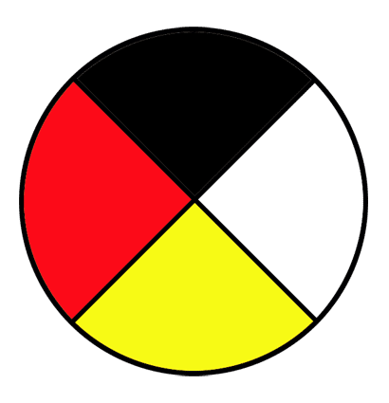

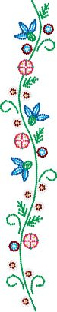

Wednesdays 1:30 PM to 3:30 PM
Oct. 11 to Dec. 13, 2017
@
16 Windsor St.

Bus Tickets provided

For more information contact:
Karen Williams @ 345-5840 ext. 9051
Peggy Adams @ 345-5840 ext. 9057

