Gzhaawsod
(Take Care of the Children)

Tuesdays from 10:00 AM to 12:00 PM
Start date: Oct. 31, 2017
Graduation: Dec. 5, 2017
@
Northwood Best Start Hub
Sherbrooke School
110 Sherbrooke St.

Snacks, Childcare and Bus Tickets provided

For more information contact:

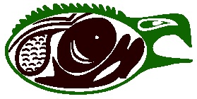
Karen Williams @ 345-5840 extension 9051
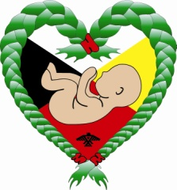
Thunder Bay Indigenous Friendship Centre

In partnership with Union of Ontario Indians
Facilitator: Lynda Banning

