Bimaadiziwin
Crafting Circle

Come out and make mittens, fur hats or moccasins for yourself or your children.

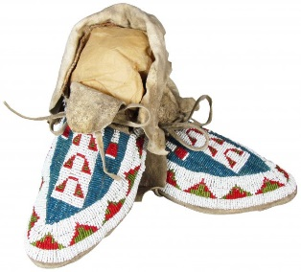
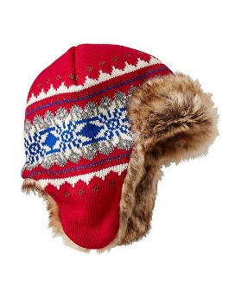
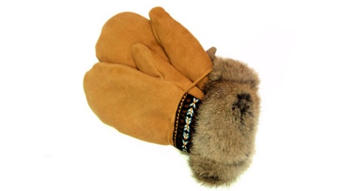

Thursdays 10:30 AM to 3:00 PM
Oct. 12 to Dec. 15, 2017

Thunder Bay Indigenous Friendship Centre
401 N. Cumberland St.

Snacks, Childcare and Bus Tickets provided

For more information contact:
Karen Williams @ 345-5840 extension 9051

